Introduction to Linux Commands
- lscpu – Displays detailed information about the CPU architecture.
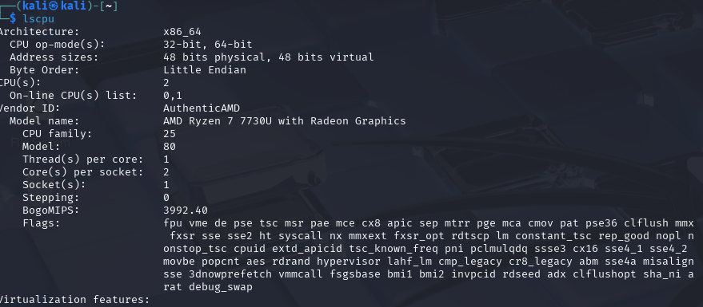
- lshw – Lists comprehensive hardware information of the system.
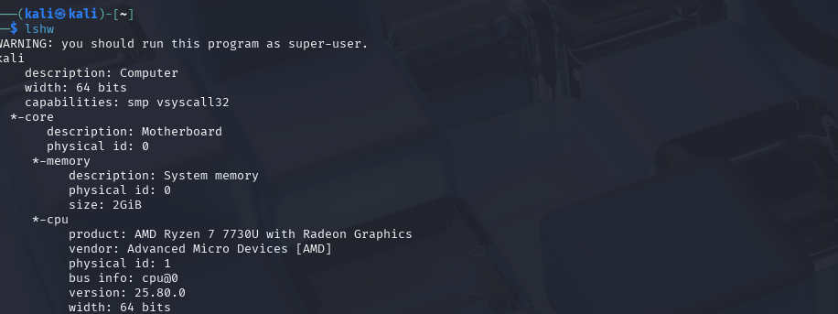
- hwinfo – Probes and presents detailed hardware information (needs installation).
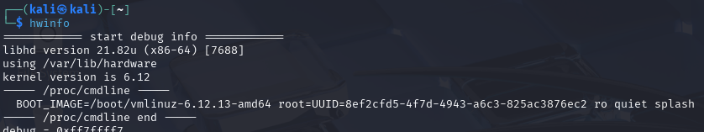
- lspci – Shows information about PCI (Peripheral Component Interconnect) devices.
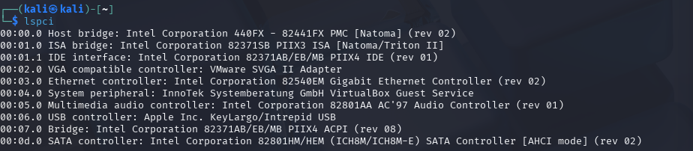
- lsscsi – Lists all SCSI (Small Computer System Interface) devices on the system.
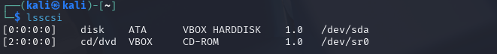

- lsusb – Displays information about USB buses and connected USB devices.

- inxi – Provides a full summary of system information in a human-readable format.
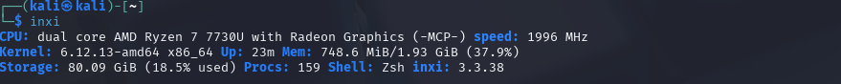
- lsblk – Lists information about block devices like hard disks and partitions.
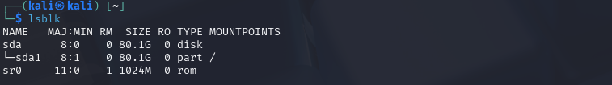

- df – Reports disk space usage of file systems.
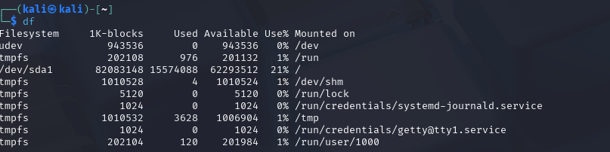

- fdisk – Manages disk partition tables interactively.

- free – Shows total, used, and free memory (RAM and swap) in the system.
- top – Displays dynamic real-time information about system processes and resource usage.
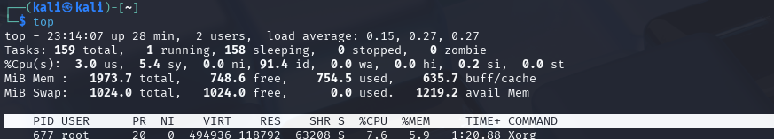
- /proc/cpuinfo – Contains detailed information about the CPU(s) from the proc virtual filesystem.
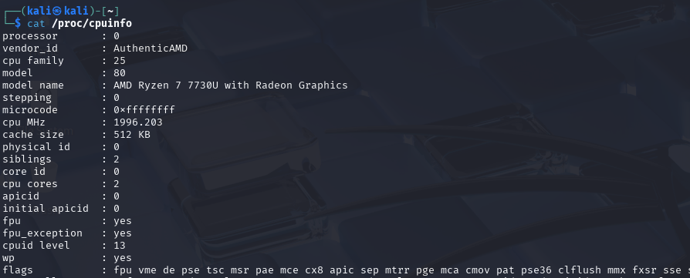

- /proc/meminfo – Provides detailed memory usage information from the proc virtual filesystem.
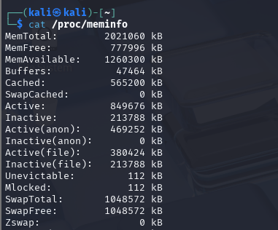

- uname – Displays system information like kernel name, version, and architecture.
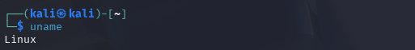

- id – Shows user and group IDs of the current or specified user.
- init – The first process started by the kernel, responsible for initializing the system (replaced by systemd in many systems).

- apt – A command-line tool for handling packages in Debian-based systems (simpler interface than apt-get).
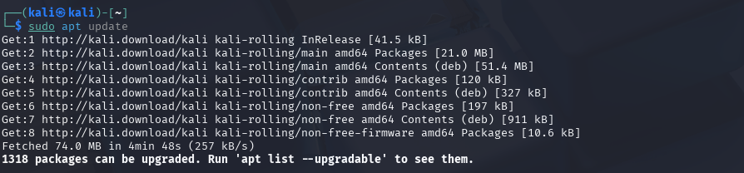

- apt-get – A more advanced tool for managing packages (install, update, remove) in Debian-based systems.
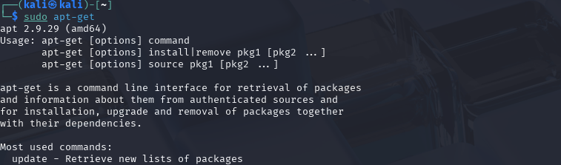

- sudo – Executes commands with superuser (root) privileges.
